Official league roster – Basketball 2022-23

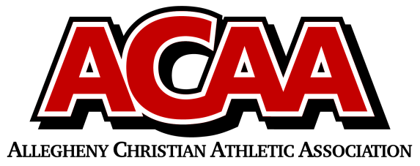
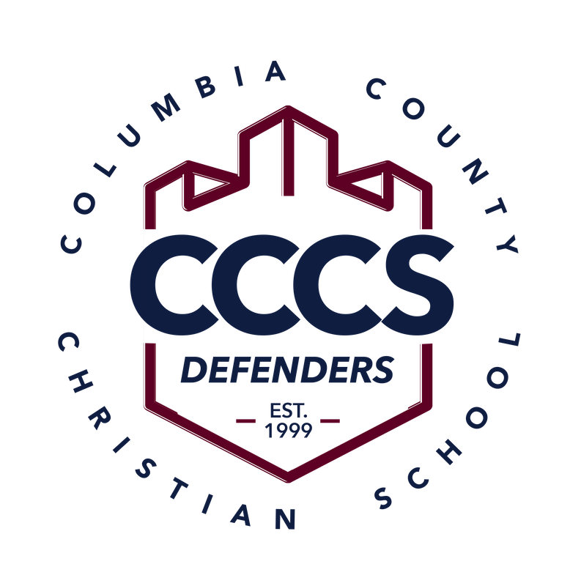

School Name: Columbia County Christian
Team Colors: Navy Blue and Maroon
Overall Wins ___ Losses ____ Ties ___
ACAA Wins ___ Losses ____ Ties ___ OPPONENT: __________________________
Date: _________
Number | Name | Year | Position | Height | Homeschool
2 | Luke Cughan | 12 | PG | 5’11”
11 | Elijah Beishline | 11 | G/F | 6’2”
10 | Chandler Davis | 11 | G | 5’9”
25 | Clay Farley | 11 | F | 6’1”
15 | Hunter Fritz | 11 | G | 5’10”
12 | Jaksen Kline | 11 | F | 6’0”
22 | Moxley Runkle | 11 | F | 6’2”
4 | Owen Lenker | 10 | G | 5’8”
3 | Pierce Cughan | 8 | G | 6’0”

Head Coach: Jim Cughan
Asst. coach: Gary Fritz
JH Coach: Jenn Cughan

